**Follow below steps to run the automated time sheet bot:**

**Note 1:** Do not change any settings in the config file. If you understand how to upload the file to the orchestrator and use an unattended robot to automate by scheduling times, then change file path in the in the settings sheet for the yellow highlighted cells.

**Note 2:** In the input folder update the WBS code and time in the columns provided only. Do not change or update the column names as that will cause the automation to fail and do not update any data under the status column rows. Further, the exceptions sheet is provided to monitor if there are any exceptions and is given to only view the process and understand if all stages have run successfully.

1. Save the Zip folder and up zip to any desired location. Preferred location to save the file is my Documents or desktop. Click on Main Xaml file to open and run. (Refer step 5).

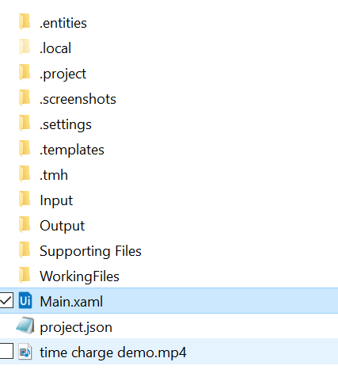

1. Navigate to Input folder and open Customised Time Charge excel file.

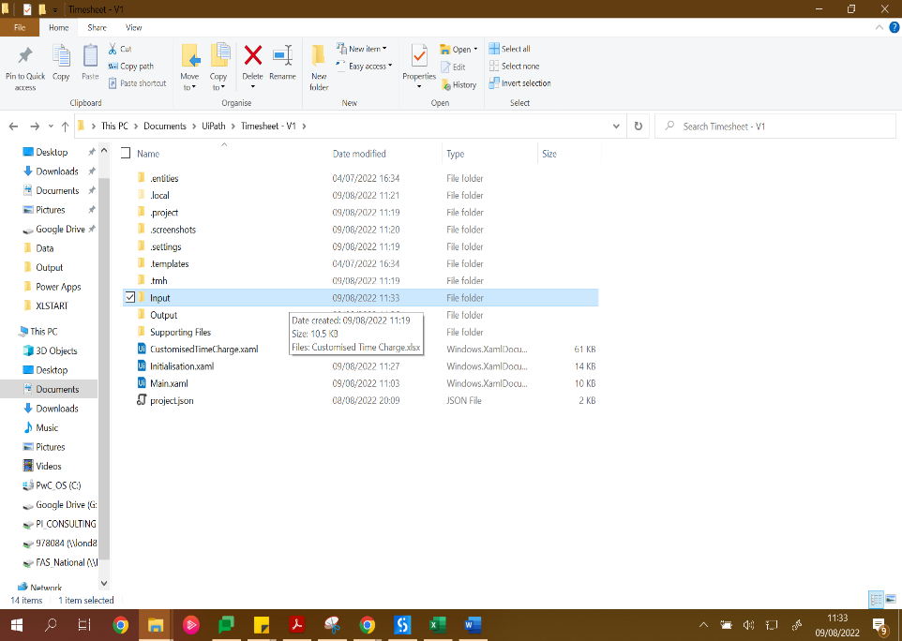 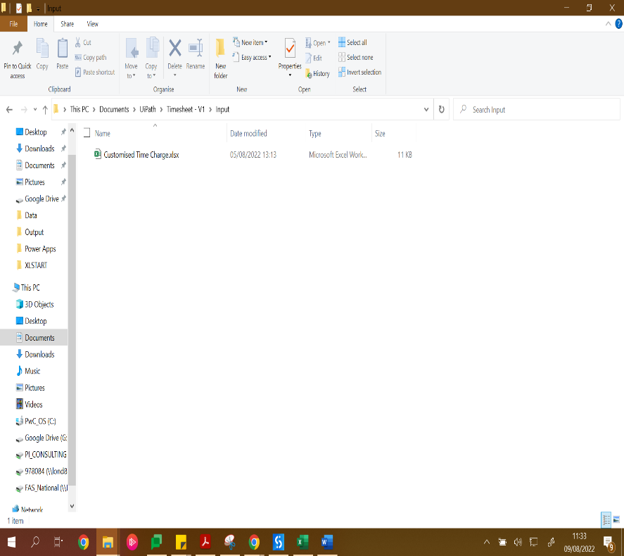

1. Enter the WBS code and the time to be charged under the respective columns. The example given is for the entire week. Do not enter any data in the Status column. This will update you whether the row was processed.

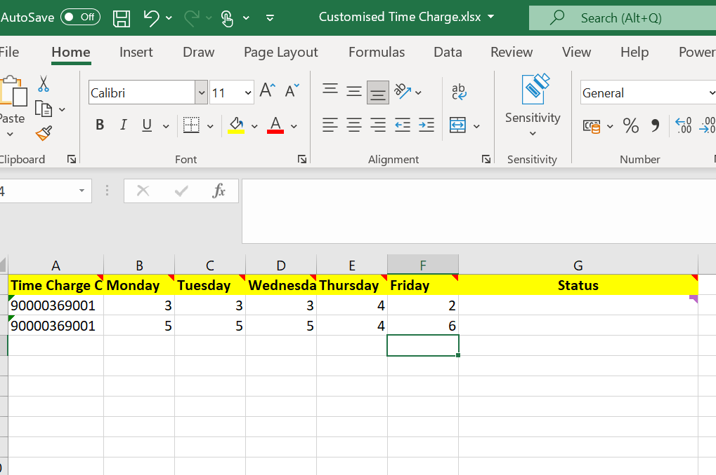

1. If you want to charge time daily. Start the process on Monday, enter the WBS code/ codes, and enter the time/ times to be charged on Monday. Input 0 for the other days and save and close excel file. See below example to be applied in the excel file – customised time charge sheet

* When charging for Monday

|  |  |  |  |  |  |
| --- | --- | --- | --- | --- | --- |
| **Time Charge** | **Monday** | **Tuesday** | **Wednesday** | **Thursday** | **Friday** |
| Abx111112 | 3 | 0 | 0 | 0 | 0 |
| Bca123211 | 3 | 0 | 0 | 0 | 0 |
| Asasa133aa | 2 | 0 | 0 | 0 | 0 |

* When charging for Tuesday and repeat same for the other days. You should not delete the data in the previous days.

|  |  |  |  |  |  |
| --- | --- | --- | --- | --- | --- |
| **Time Charge** | **Monday** | **Tuesday** | **Wednesday** | **Thursday** | **Friday** |
| Abx111112 | 3 | 2 | 0 | 0 | 0 |
| Bca123211 | 3 | 6 | 0 | 0 | 0 |
| Asasa133aa | 2 | 0 | 0 | 0 | 0 |

1. Open Ui Path studio and run the process. You should open the Main.Xaml file and click Run button. This is the 'Debug File' button which has drop down that leads to a 'Run button’.

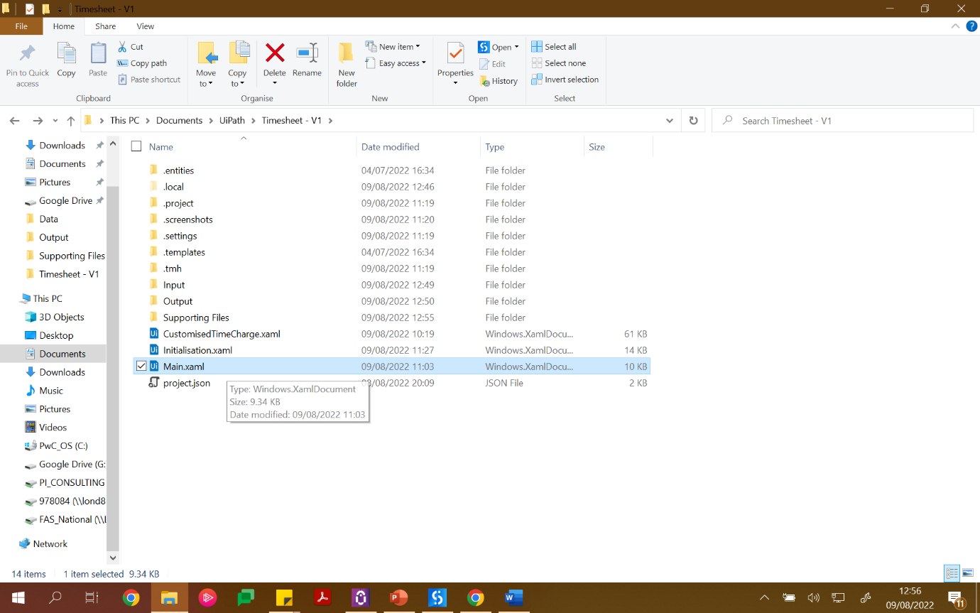

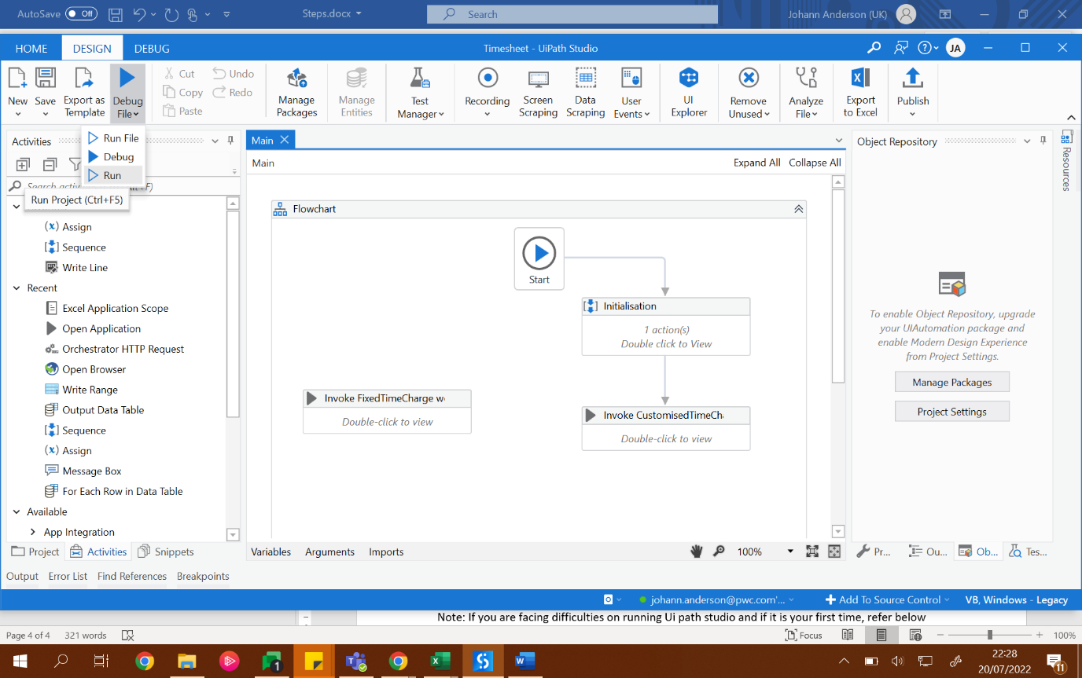

**Note for experienced staff:** If you manage to upload this to your orchestrator for which you will need to create an online account, you can run it using Uipath Assistant. See below tutorial

<https://www.youtube.com/watch?v=5ixkFVEPCAU>

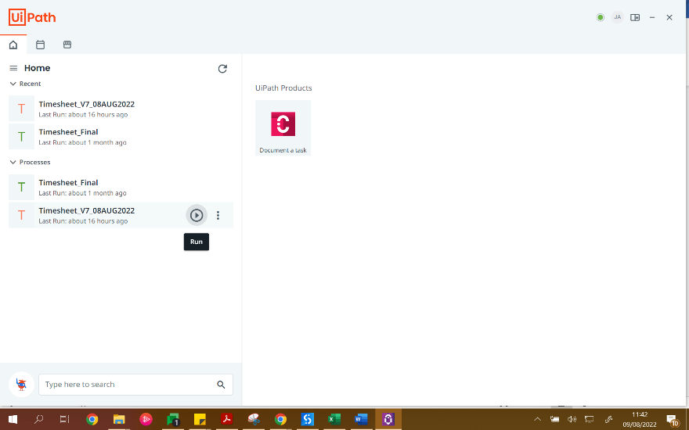

Note: If you are facing difficulties on running Ui path studio and if it is your first time, refer below link: <https://www.youtube.com/watch?v=K0rFtXu1R5s>

1. Refer the Exceptions sheet in the Customised time charge excel to view the status of the process and identify if it has performed all actions. If you identify any exceptions in Sheet 1 ‘status’ column or in the exceptions page, you should run the process again.

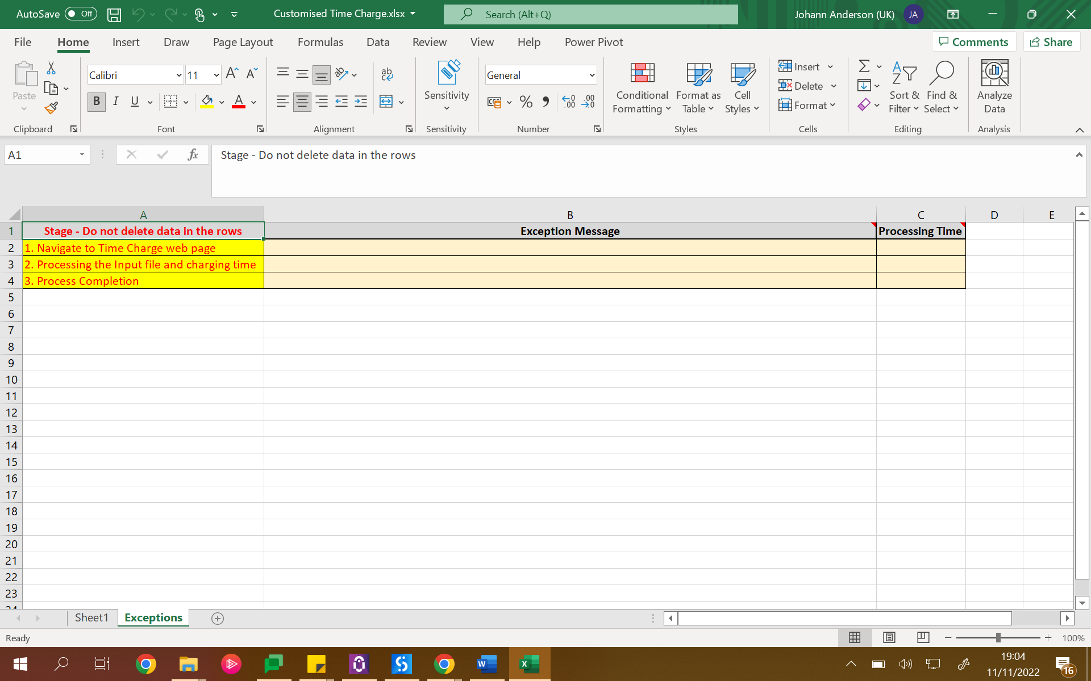

1. Refer the Output file to view the Screenshot and text message to confirm the process has successfully been run.

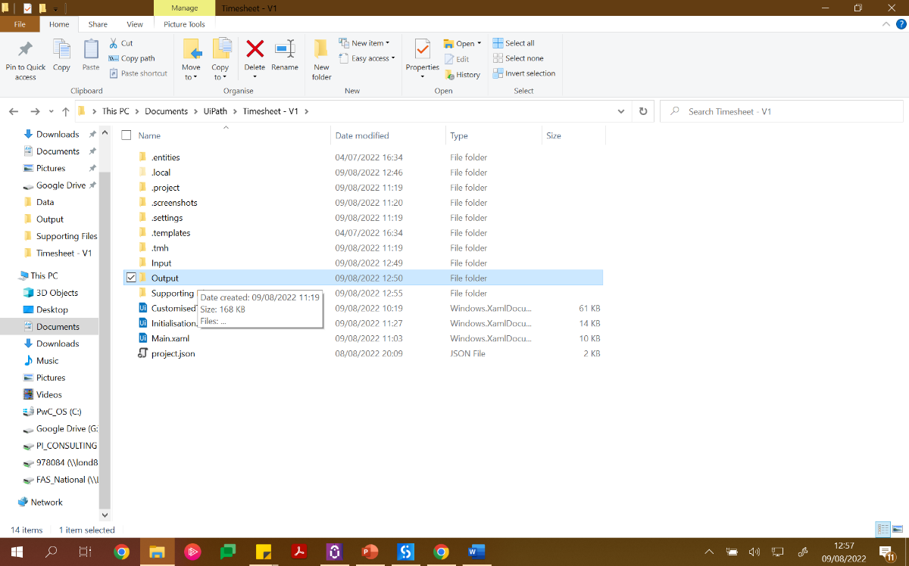

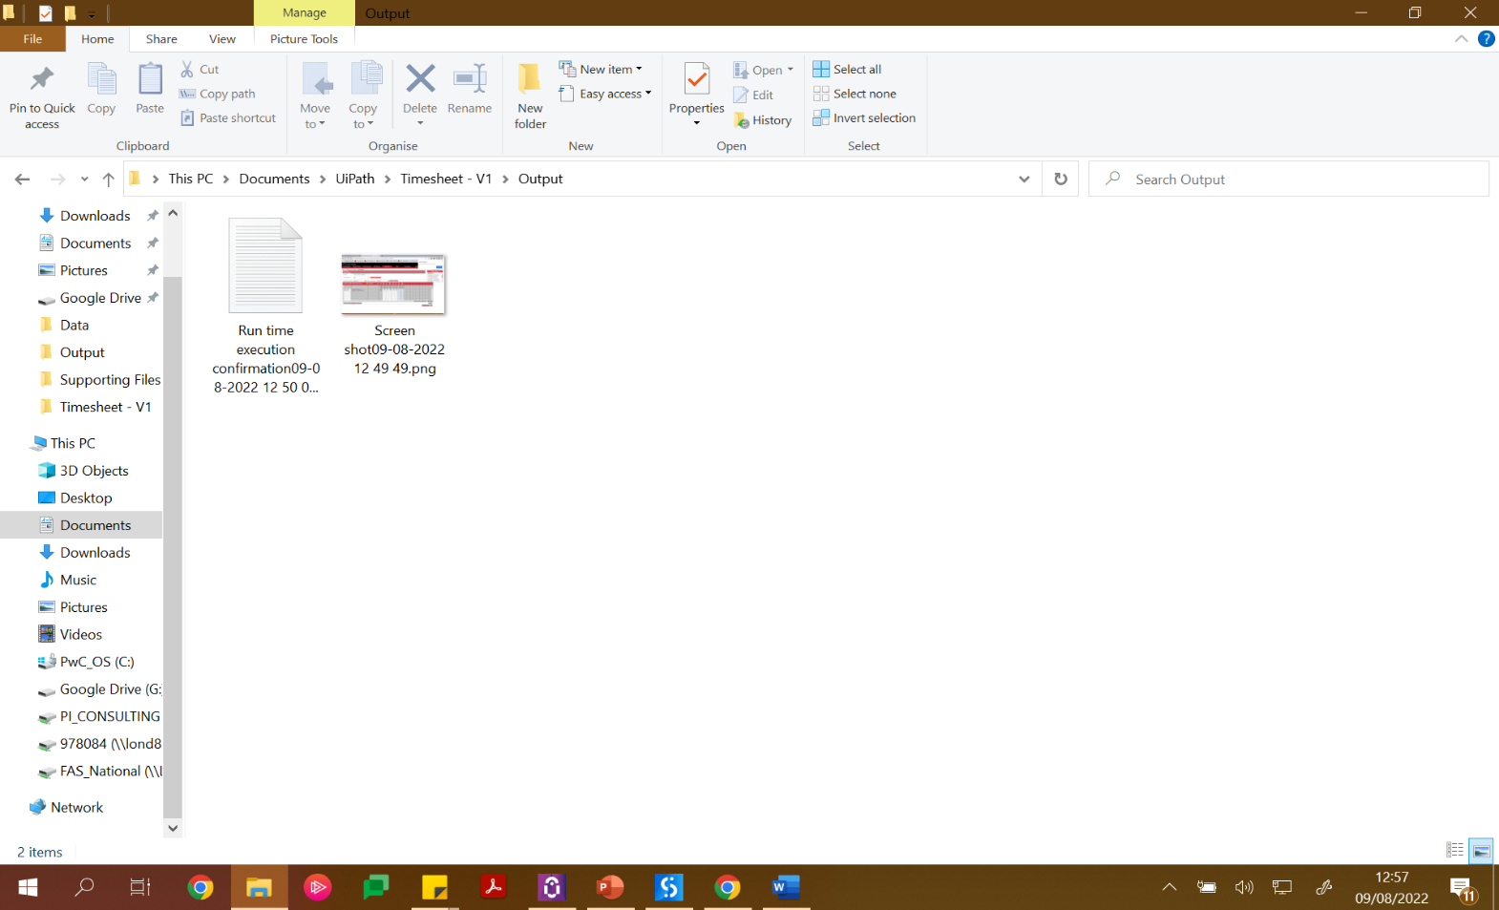

**Below steps are not mandatory. But if you want to give your desktop path will be useful if you upload the automation to the Ui Path orchestrator and schedule for unattended robot to pick it up.**

1. Navigate to Supporting Files folder and open config file.
2. Open the config file. Point 4, 5 and 6 should only be changed (i.e. rows highlighted in yellow)
3. FilePathTimeSheet row path must be changed. The path to be copied is the Customised Time Charge.xlsx file path.

You can copy path using shift + right click.

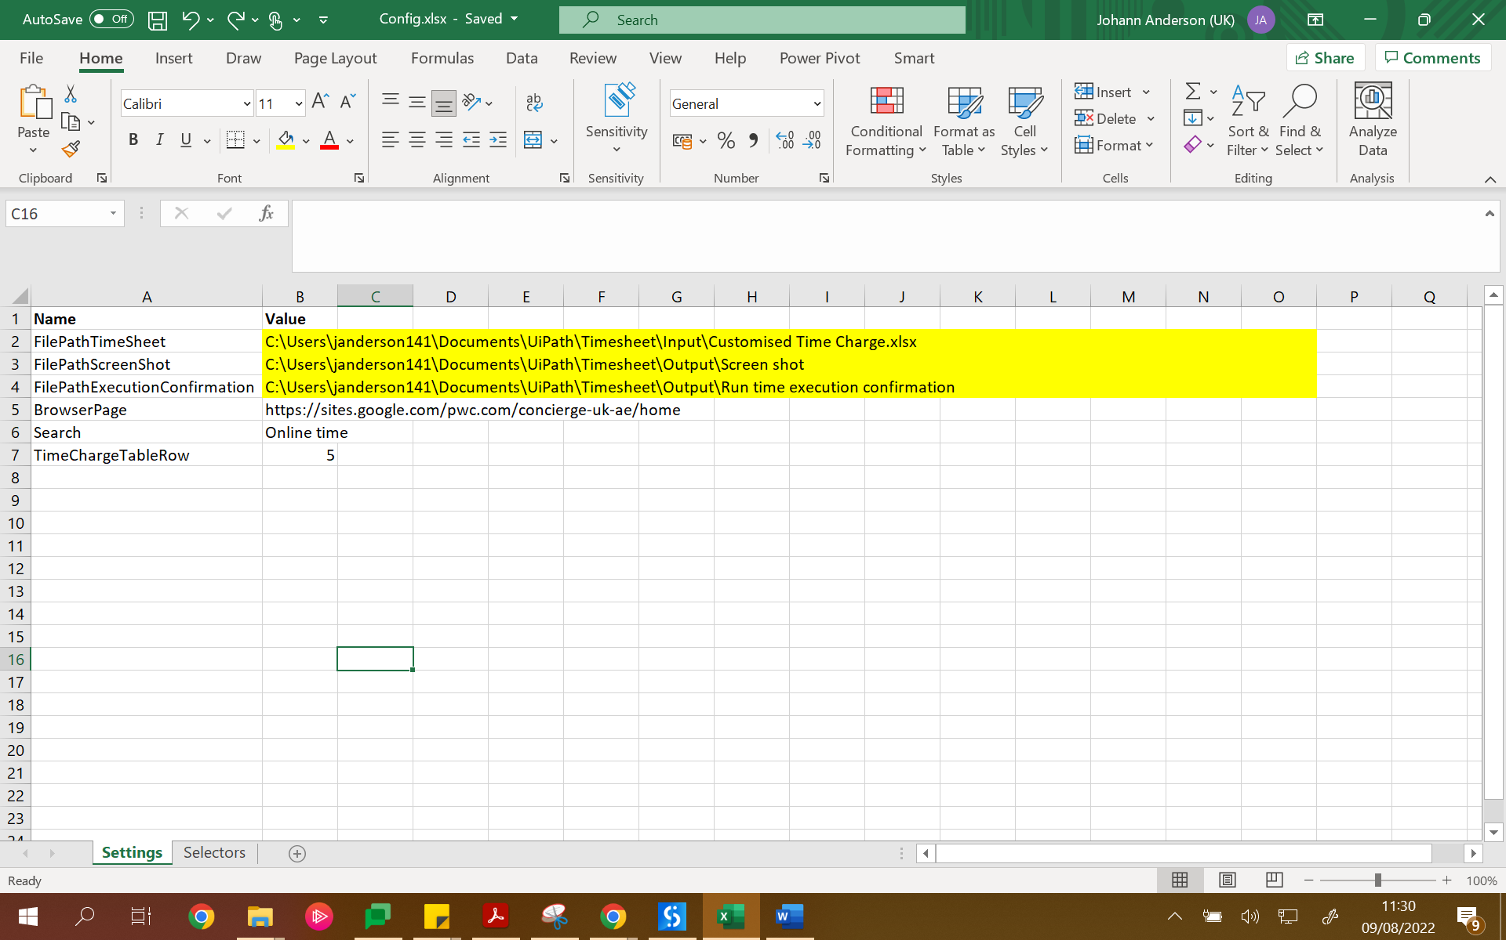

1. FilePathScreenShot row path must be changed. The path to be copied is the Output folder path + \Screen shot.

This means you need to merge the file path with \Screen shot

e.g. C:\Users\xxxx\Documents\UiPath\Timesheet\Output\Screen shot

1. FilePathExecutionConfirmation row path must be changed. The path to be copied is the Output folder path + Run time execution confirmation. This means you need to merge the file path with Run time execution confirmation.

e.g. C:\Users\xxxx\Documents\UiPath\Timesheet\OutputRun time execution confirmation

1. Save and close the config excel file.